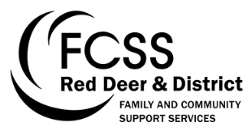
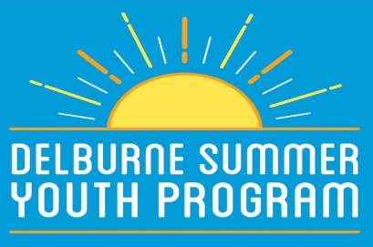
Group 4 Youth Schedule 2017
* Please meet at Delburne Arena for all out of town events
July 2017:
Thursday July 6 (1:00- 4:00pm) Downtown Park, Delburne

Meet & Greet – this event is intended to give participants the opportunity to become acquainted with other children in the program, as well as the 2017 SYP Staff. Join us in the park for an assortment of ice-breaker activities!

Wednesday July 12 (8:00am- 7:00pm) Calgary
*Calaway Park – join us for a fun-filled day at Calgary’s Calaway Park! Please pack a lunch and money if your child would like to purchase any food or gifts. The Calaway Park trip will require an additional fee of $20 to participate.

Thursday July 13 (1:00- 4:00pm) Delburne Pottery Club
Beginners Pottery Session – learn the basics of pottery making in a specialized session with the Delburne Pottery Club. Let your creativity fly! The Delburne Pottery Club is located at the North End of the Delburne Curling Rink.
Thursday July 20 (1:00- 4:00pm) Downtown Park, Delburne
Group 4 Youth Olympic Games – you are invited to the first annual Group 4 Youth Olympic Games! Upon arrival, participants will be assigned a country to represent in the games. Compete for gold, silver, and bronze medals in fun events such as tug of war, potato sack race, water balloon toss, and much more!
Friday July 27/28 (4:00pm- Noon) Pine Lake Hub Centre
The Campout – we are excited to be offering an overnight camping trip for summer 2017. Please note that there will be NO BUS for this event- we will require parent drivers to drop off and pick up campers from the venue. More information regarding the campout (packing list, food, etc) will be posted prior to the event.
August 2017:
Thursday August 1 (1:00- 4:00pm) Downtown Park
Agriculture Day– Seize the chance to learn more about Delburne’s local agriculture and horticulture sectors! Location may be subject to change.
Tuesday August 8 (1:00- 4:00pm) Downtown Park
Learn to Geocache – get the unique opportunity to learn about technology, and the power of GPS coordinates! Join us for a fun afternoon of geocaching, and help our team search for hidden treasures around town. Access to GPS devices and geocaching instruction will all be included in this event.
Wednesday August 9 (9:30am – 4:00pm) Sylvan Lake
*Aqua Splash Water Park – join us on a trip to the brand new Aqua Splash Water Park in Sylvan Lake! We will spend the first portion of our day at the inflatable water park, and then enjoy a beach picnic on the Sylvan Lake Public Beach. Please pack a lunch, swimsuit, and towel (or money if your child is interested in purchasing food). For more information about Sylvan Lake Aqua Splash, visit their website at http://www.sylvanlakeaquasplash.ca/
Tuesday August 15 (1:00- 4:00pm) Meet at the Downtown Park
The Amazing Race – come embark on a village-wide adventure! This event will require teamwork, intellect, and perseverance. Do you have what it takes to complete the Delburne Amazing Race?
Wednesday August 23 (1:00- 4:00pm) Downtown Park, Delburne
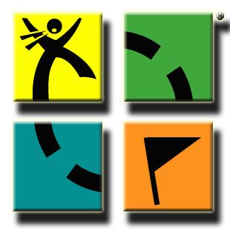
BBQ Windup – join us for the final Summer Youth Program event of the summer. Food will be provided!

