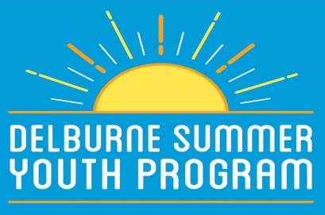
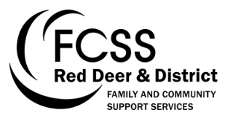
Park Program Schedule 2017
* Please meet at Delburne Arena for all out of town events
July 2017:
Monday July 3 (1:00- 4:00pm) Downtown Park, Delburne

Meet & Greet – this event is intended to give kids the opportunity to become acquainted with other children in the program, as well as the 2017 SYP Staff. Join us in the park for an assortment of ice-breaker activates!

Monday July 10 (1:00- 4:00pm) Meet at Downtown Park
Anthony Henday Museum & Woodlake School Re-Enactment – join us for a specialized tour of the local Anthony Henday Museum, including access to the water tower, CN train car, and a customized Woodlake School House Re-Enactment.
Monday July 17 (1:00- 4:00pm) Downtown Park, Delburne
Fairytale Adventures – please come to the downtown park dressed as your favorite fairytale character! Join us for a Mad Hatter’s Tea Party, a Pirate Treasure Hunt, a Royal Ball, and much more.
Monday July 24 (1:00- 4:00pm) Downtown Park, Delburne
Splish Splash Day – join us at the Delburne Spray Park for a fun afternoon of water games and activities. Don’t forget your swimsuit and towel!
Wednesday July 26 (9:00am- 4:00pm) Buffalo Lake, Erskine
*Old MacDonald’s Resort & Sandy Beach – we are excited to offer an out of town field trip to Buffalo Lake for summer 2017. This trip will include access to Sandy Beach, the playground, the candy shop, and more! Please pack a lunch, swimsuit, and towel (or money if your child would like to purchase a treat from the candy store).

Monday July 31 (1:00- 4:00pm) Downtown Park, Delburne
Yoga & Wellness in the Park – we welcome you to the downtown park for an afternoon of wellness and relaxation. Delburne Massage and Wellness Clinic staff will be joining us to run a specialized yoga session, as well as some other wellness-related activities.
August 2017:
Friday August 11 (1:00- 3:00pm) Delburne Drop- In Centre
Connecting with Community: Arts & Crafts Session with Local Seniors – we are thrilled to be including our first intergenerational event in the program this year. Please join our communities’ seniors for an interactive arts and crafts activity at the Drop-In.

Monday August 14 (1:00- 4:00pm) Meet at the Downtown Park
Scavenger Hunt – come embark on a (chaperoned) village wide scavenger hunt! Seize the opportunity to explore the community and visit local businesses and attractions.

Wednesday August 23 (1:00- 4:00pm) Downtown Park, Delburne
BBQ Windup – join us for the final Summer Youth Program event of the summer. Food will be provided!

