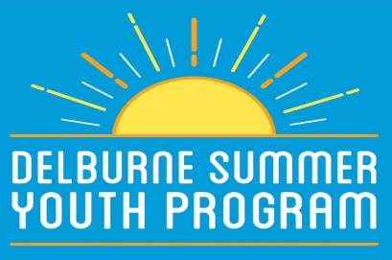
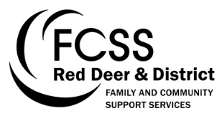
Summermania Schedule 2017
* Please meet at Delburne Arena for all out of town events
July 2017:
Tuesday July 4 (1:00- 4:00pm) Downtown Park, Delburne

Meet & Greet – this event is intended to give participants the opportunity to become acquainted with other children in the program, as well as the 2017 SYP Staff. Join us in the park for an assortment of ice-breaker activities!

Tuesday July 11 (1:00- 4:00pm) Meet at Downtown Park
Anthony Henday Museum & Woodlake School Re-Enactment – join us for a specialized tour of the local Anthony Henday Museum, including access to the water tower, CN train car, and a customized Woodlake School House Re-Enactment.
Wednesday July 12 (8:00am- 7:00pm) Calgary
*Calaway Park – join us for a fun-filled day at Calgary’s Calaway Park! Please pack a lunch and money if your child would like to purchase any food or gifts. The Calaway Park trip will require an additional fee of $20.
Tuesday July 18 (1:00- 4:00pm) Downtown Park, Delburne
Summermania Olympic Games – you are invited to the first annual Summermania Olympic Games! Upon arrival, participants will be assigned a country to represent in the games. Compete for gold, silver, and bronze medals in fun events such as tug of war, potato sack race, water balloon toss, and much more!
Friday July 27/28 (4:00pm- Noon) Pine Lake Hub Centre
The Campout – we are excited to be offering an overnight camping trip for summer 2017. Please note that there will be NO BUS for this event- we will require parent drivers to drop off and pick up campers from the venue. More information regarding the campout (packing list, food, etc) will be posted prior to the event.
August 2017:
Tuesday August 1 (1:00- 3:00pm) Downtown Park
Yoga & Wellness in the Park – we welcome you to the downtown park for an afternoon of wellness and relaxation. Delburne Massage and Wellness Clinic staff will be joining us to run a specialized yoga session, as well as some other wellness-related activities.
Tuesday August 8 (1:00- 4:00pm) Downtown Park
Mad Scientist Day – want to become a Mad Scientist for the afternoon? Join us for a fun afternoon of science in the park- get the chance to partake in interactive activities, crafts, and even get to view a science demonstration from a real life Mad Scientist!
Wednesday August 9 (9:30am – 4:00pm) Sylvan Lake
*Aqua Splash Water Park – join us on a trip to the brand new Aqua Splash Water Park in Sylvan Lake! We will spend the first portion of our day at the inflatable water park, and then enjoy a beach picnic on the Sylvan Lake Public Beach. Please pack a lunch, swimsuit, and towel (or money if your child is interested in purchasing food). For more information about Sylvan Lake Aqua Splash, visit their website at http://www.sylvanlakeaquasplash.ca/
Tuesday August 15 (1:00- 4:00pm) Meet at the Downtown Park
The Amazing Race – come embark on a village-wide adventure! This event will require teamwork, intellect, and perseverance. Do you have what it takes to complete the Delburne Amazing Race?
Wednesday August 23 (1:00- 4:00pm) Downtown Park, Delburne
BBQ Windup – join us for the final Summer Youth Program event of the summer. Food will be provided!

